**Assignment No:-4.4**

1) Write a program that demonstrates widening conversion from int to double and prints the result.

2) Create a program that demonstrates narrowing conversion from double to int and prints the result.

3) Write a program that performs arithmetic operations involving different data types (int, double, float) and observes how Java handles widening conversions automatically.

4) Write a Program that demonstrates widening conversion from int to (double,float, boolean, string) and prints the result.

**Code:-**

**public** **class** Widening {

**public** **static** **void** main(String[] args) {

// 1) int to double(Widening=Smaller data type into large data type)

**int** a=100;

**double** b=a;

System.***out***.println("Conversion of int to double is : "+b);

// 2) double to int(Narrowing=Large data type to small data type)

**double** d=45555;

**int** c=(**int**)d;

System.***out***.println("conversion of double to int is :"+d);

// 3) Arithmetic operation for widening conversion

**int** e=15;

**double** f=65;

**double** sum;

sum=e+f;

System.***out***.println("Addition of two number is :"+sum);

**float** g=8555;

**double** h=45;

**double** mul;

mul=g*h;

System.***out***.println("Multiplication of two number is :"+mul);

// 4) demonstrate widening conversion from int to (double,float,boolean,String)

**int** i=10;

**double** j=i;

System.***out***.println("int to double "+j);

**int** aa=45;

**float** bb=aa;

System.***out***.println("int to float "+bb);

**int** intvalue=1;

**boolean** boolv=(intvalue != 0);

System.***out***.println("Boolean value is :"+boolv);

**int** intval=45;

String abc=String.*valueOf*(intval);

System.***out***.println("value in String :"+abc);

**int** intval2=666;

String str=Integer.*toString*(intval2);

System.***out***.println("value in String :"+str);

}

}

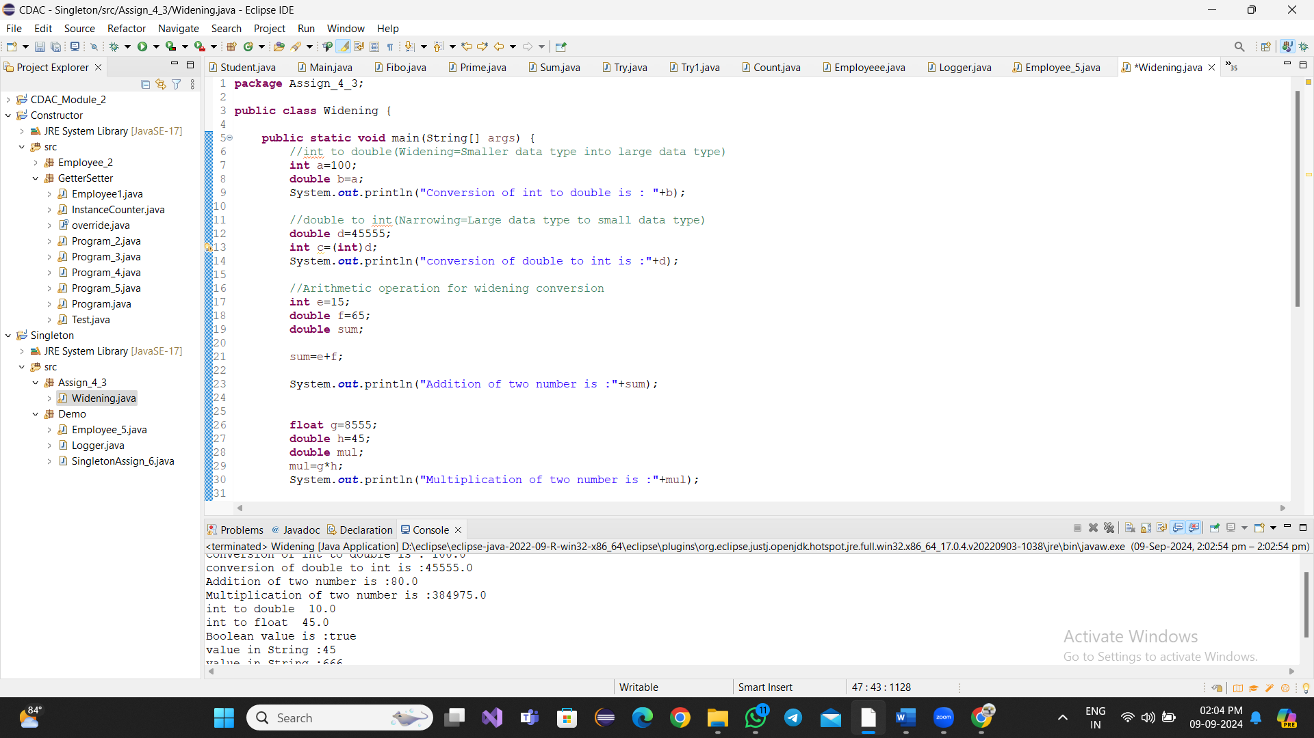

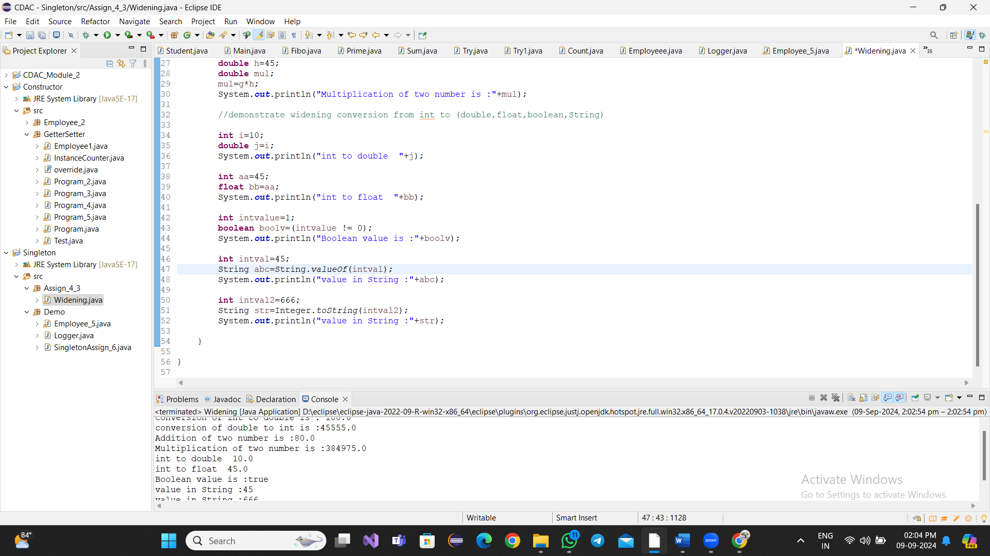

**Interview Questions**

**Note: Write down this interview question on your notebook ,Take a screenshort & Paste that SS in the word document & upload on your Github.**

**What does the static keyword mean in Java? Explain the difference between static and non-static methods.**

